Team Members: Melvin St.John, Ayham Sabra, Cody White

Team name: Electron wranglers

Textron Cooling Fan project

Team Minutes

Table of Contents

Date of Submission: 05 Sept 23021 3

Meeting Attendance 3

Progress: 3

Date of Submission: 12 Sept 23021 5

Meeting Attendance 5

Progress: 5

Date of Submission: 19 Sept 23021 8

Meeting Attendance 8

Progress: 8

Date of Submission: 26 Sept 23021 13

Meeting Attendance 13

Progress: 13

Date of Submission: 03 Oct 2021 17

Team Attendance 17

Progress: 18

Date of Submission: 17 Oct 2021 21

Meeting Attendance 21

Progress: 22

Date of Submission: 24 Oct 2021 26

Progress: 27

Date of Submission: 31 Oct 2021 29

Meeting Attendance 29

Progress: 29

Date of Submission: 14 Nov 2021 33

Meeting Attendance 34

Progress: 34

ECE 595 Spring Semester 2022 37

Date of Submission: 06 February 2022 37

Meeting Attendance 37

Progress: 37

Date of Submission: 06 February 2022 40

Meeting Attendance 40

Progress: 40

Date of Submission: 20 February 2022 43

Meeting Attendance 43

Progress: 43

Date of Submission: 20 February 2022 45

Meeting Attendance 45

Progress: 45

Date of Submission: 47

Meeting Attendance 47

Progress: 47

Date of Submission: 49

Meeting Attendance 49

Progress: 49

Date of Submission: 51

Meeting Attendance 51

Progress: 51

Date of Submission: 53

Meeting Attendance 53

Progress: 53

Date of Submission: 55

Meeting Attendance 55

Progress: 55

Date of Submission: 57

Meeting Attendance 57

Progress: 57

Team Name: **Electron Wranglers**

# Date of Submission: 05 Sept 23021

Meeting Date & Time: 3 Sep 2021 0930-1200 and 1630-

Meeting Location Classroom Session Rm. 127 and WH 325 with Dr. Ara

Meeting Duration: 2.5 hrs. and

## Meeting Attendance

|  |  |  |
| --- | --- | --- |
| Team Members | X = Present | Notes |
| Melvin St.John | X |  |
| Ayham Sabra | X |  |
| Cody White | X |  |
|  |  |  |
|  |  |  |

### Progress:

**Meeting #1** was used to finalize the team members for the project. There is a second meeting with Dr. Ara in WH 325 at 1630 today to further discuss the projects’ criteria and to set up communications with the project leader at Textron.

**Meeting #2** was with Dr. Ara and his PHD student Arun. We discussed the project in more depth regarding the design parameters. Mel asked about design consideration pertaining to atmospheric radiation at he 55000 ft. altitude. Ayham discussed future meetings and contacts for questions and concerns. Cody inquired into access to PCB design areas and levels of sophistication.

**Individual contributions:** This isn’t really applicable at this time because this group was just formed today but, as a side note, each of us have been doing preliminary research into different aspects of the project, i.e., filters, high altitude effects on electronic circuits, and temperature effects.

Project Tracking (current work): Assignments and activities are to be tracked until completed.

|  |  |  |  |
| --- | --- | --- | --- |
| Team Member | Assignment | Due Date | % Complete |
| Cody White |  |  |  |
| Ayham Sabra |  |  |  |
| Mel St.John |  |  |  |
|  |  |  |  |
|  |  |  |  |
|  |  |  |  |
|  |  |  |  |

Plan (future work):

A brief description of the tasks and activities the team needs to accomplish work over the coming weeks. As team members pick up assignments, move from this table to the tracking table. Consider future work a running task-list with an expected due date for completion.

|  |  |
| --- | --- |
| Assignment | Due Date |
| Dr. Ara requested that we read up on BLDC motors, specifically, the voltage to rpm relationship before the next meeting. | 10 Sept 2021 |
| General research into atmospheric effects, temperature effects, on electronic components/circuitry; and tachometer monitoring strategies. | Open at this time |
|  |  |
|  |  |
|  |  |
|  |  |
|  |  |
|  |  |
|  |  |
|  |  |
|  |  |
|  |  |
|  |  |

Issues:

No issues have arisen currently.

Include the schedule for the next meeting:

Meeting Date & Time: 10 Sept 2021, 15:30pm, Dr. Ara and Arun to discuss BLDC motors, etc.

Meeting Location: WH 125

Team Name: **Electron Wranglers**

# Date of Submission: 12 Sept 23021

Meeting Date & Time: 10 Sep 2021 16:00

Meeting Location WH 325 with Dr. Ara and Arun (PhD. Student)

Meeting Duration: 1.0 hrs.

## Meeting Attendance

|  |  |  |
| --- | --- | --- |
| Team Members | X = Present | Notes |
| Melvin St.John | X |  |
| Ayham Sabra | X |  |
| Cody White | X |  |
| Dr. Ara | X |  |
|  |  |  |

### Progress:

**Individual contributions:** The previous meeting (10/3) team members were asked by Dr. Ara to learn about BLDC motors so that we could discuss them.

Initially, we discussed basic characteristics of the BLDC. Each member asked questions of Dr. Ara and contributed.

Questions pertaining to the projects were discussed:

Ayham asked multiple questions about the testing that would need to be done and where it would be done. Cody inquired into the lightning protection aspects and Dr. Ara assumes it will not be an issue, but we should ask Jens at our meeting with him. Mel asked about access to the DO regs as they are a pay to see item. It will be asked of Jens for access or criteria that must be followed. Mel asked about the software to be used whether it should be multisim, etc., or a software that Textron uses as our deliverable are schematics and pcb designs, etc. Ayham asked about he need for magnetic shielding. (question for Jens to answer).

Questions so far for Jens:

1. Access to Do regs/criteria?
2. What software should it be delivered in?
3. Need for magnetic shielding?
4. How precise does it need to be? Dead band?
5. Need for lighting protection? ( another Do test)
6. Need for pressure chamber testing? Where?
7. Can Textron provide a test motor for our use or provide characteristics for us to purchase a comparable motor to test with.
8. Is there a need for redundancy in the system?
9. Do they have a test bed, or do we need to build one?

**Project Tracking** (current work): Assignments and activities are to be tracked until completed.

|  |  |  |  |
| --- | --- | --- | --- |
| Team Member | Assignment | Due Date | % Complete |
| Cody White (Float) | BLDC characteristics research | 1 Oct 2021 | 10 |
| Ayham Sabra (Lead) | Testing criteria for the specific DO regs | 1 Oct 2021 | 10 |
| Mel St.John (Scribe) | Control circuit research | 1 Oct 2021 | 10 |
| Cody White (Float) | Questions for Textron | 12 Sept 2021 |  |
| Ayham Sabra (Lead) | Questions for Textron | 12 Sept 2021 |  |
| Mel St.John (Scribe) | Questions for Textron | 12 Sept 2021 |  |
|  |  |  |  |

Plan (future work):

This week the members divided the project into individual section for each member to focus on. We are each required to have questions ready to ask Jens at our scheduled meeting (tentative date is 17 Sept 2021). We will be meeting with Dr. Ara on 12 September to go over the questions we have to date and the timeline for this semester.

|  |  |
| --- | --- |
| Assignment | Due Date |
| BLDC Characteristics Research (Cody White) | 1 Oct 2021 |
| Research testing criteria required by DO regs (Ayham Sabra) | 1 Oct 2021 |
| Research control circuits and form a preliminary design plan (Mel St.John) | 1 Oct 2021 |
|  |  |
|  |  |
|  |  |
|  |  |
|  |  |
|  |  |
|  |  |
|  |  |
|  |  |
|  |  |

Issues:

No issues have arisen currently.

Include the schedule for the next meeting:

Meeting Date & Time: 12 Sept 2021, 17:00, Dr. Ara to establish a timeline and solidify questions for Jens from Textron.

Meeting Location: John Bardo lobby

Team Name: **Electron Wranglers**

# Date of Submission: 19 Sept 23021

Meeting Date & Time: 12 Sept 2021 17:00

14 Sept 2021 17:30

Meeting Location John Bardo Lobby with Dr. Ara and Arun (PhD. Student)

P2, A130 with Textron

Meeting Duration: 0.75 hrs.

1.5 hrs. (Textron Mtg.)

## Meeting Attendance

|  |  |  |
| --- | --- | --- |
| Team Members | X = Present | Notes |
| Melvin St.John | X |  |
| Ayham Sabra | X |  |
| Cody White | X |  |
| Dr. Ara | X |  |
| Arun | X | Was Joined by Jens and Clint from Textron as well as all team members, Dr. Ara, and Arun for the mtg. on 14 Sept 2021 16:30. |

### Progress:

**Individual contributions:**

Mtg. (12 Sept 2021): We went over our timeline for the project through May of 2022. Dr. Ara made some suggestions (that we were being overly ambitious for this semesters’ dates) so we made a few adjustments to the dates we had originally decided.

Secondly, we discussed our questions for Textron (see previous weeks’ minutes for questions).

We went over our presentation (slides) for the Textron meeting and Dr. Ara suggested a couple alterations to our block diagram of the project.



Mtg. (14 Sept 2021 17:30) with Textron

Introductions were made.

We presented our slides (all members spoke or made comments).

We realized our understanding of one of the requirements was incorrect. We need the circuit to go to ground if within parameters, and to an ‘open’ if not within parameters. We had this backwards. The following questions were asked/answered:

1. Access to Do regs/criteria?

If we cannot get access through NIAR, they (Textron) will provide the specific information we need for design considerations, although we won’t be doing those tests. We may be allowed to come and observe those tests as they do them though.

1. What software should it be delivered in?

We can use whatever is available, but they prefer Altium Circuit Maker. They would also prefer LT Spice for simulations.

1. Need for magnetic shielding?

It will be handled by copper flood fill.

1. How precise does it need to be? Dead band?

At this point, our tolerance will be +/- 50 rpm and we can use 10-20% components. Later when the final project is being built, we will need 0.1 % components and they will have to do the PCB as WSU can only make 2-layer boards. Two-layer boards are sufficient for prototypes.

1. Need for lighting protection?

As that is a DO160 test we will not be doing that testing.

1. Need for pressure chamber testing?

Another test that we will be allowed to observe at Textron.

1. Can Textron provide a test motor for our use or provide characteristics for us to purchase a comparable motor to test with.

Textron will send us a test motor to use as well as the characteristics of the said motor.

1. Is there a need for redundancy in the system?

There is no need for redundancy.

1. Are logic gates acceptable?

Yes.

1. Is there a process, or contact, to acquire material?

If there is a component, or a need, that we cannot find, we can email Clint or Jens and they will help us get what we need.

Further discussion: although the bus provides 28v nominal, it could vary to as low as 10v during engine startup and go as high as 80v. Our design must withstand this variability.

We should use only ‘generic’ components for supply chain reason.

The package must be easy to disassemble yet able to withstand the vibration tests and pressure tests (not a sealed package).

We are to work on a more thorough block diagram that includes the filtering and the comparator circuits then set up a zoom meeting with Clint to go over it for ‘dos and don’ts for aircraft circuits).

By the 2ne to 3rd week of October we will meet with them again to go over our circuit diagram to look for any of the same dos and don’ts as before.

**Project Tracking** (current work): Assignments and activities are to be tracked until completed.

|  |  |  |  |
| --- | --- | --- | --- |
| Team Member | Assignment | Due Date | % Complete |
| Cody White (Float) | BLDC characteristics research | 1 Oct 2021 | 25 |
| Ayham Sabra (Lead) | Testing criteria for the specific DO regs | 1 Oct 2021 | 25 |
| Mel St.John (Scribe) | Control circuit research | 1 Oct 2021 | 25 |
| Cody White (Float) | Questions for Textron | 12 Sept 2021 |  |
| Ayham Sabra (Lead) | Questions for Textron | 12 Sept 2021 |  |
| Mel St.John (Scribe) | Questions for Textron | 12 Sept 2021 |  |
|  |  |  |  |

Plan (future work):

This week the members divided the project into individual section for each member to focus on. We are each required to have questions ready to ask Jens at our scheduled meeting (tentative date is 17 Sept 2021). We will be meeting with Dr. Ara on 12 September to go over the questions we have to date and the timeline for this semester.

|  |  |
| --- | --- |
| Assignment | Due Date |
| BLDC Characteristics Research (Cody White) | 1 Oct 2021 |
| Research testing criteria required by DO regs (Ayham Sabra) | 1 Oct 2021 |
| Research control circuits and form a preliminary design plan (Mel St.John) | 1 Oct 2021 |
|  |  |
|  |  |
|  |  |
|  |  |
|  |  |
|  |  |
|  |  |
|  |  |
|  |  |
|  |  |

Issues:

No issues have arisen currently.

Include the schedule for the next meeting:

Meeting Date & Time: 24 Sept 2021, 15:30, Team meeting to go over research findings and solidify our ‘more

functional’ block diagram.

26 Sept 2021, 17:30, Dr. Ara to make sure we are on the right track.

Meeting Location: Library WSU

John Bardo lobby TTBD

Team Name: **Electron Wranglers**

# Date of Submission: 26 Sept 23021

Meeting Date & Time: 24 Sept 2021 12:00

26 Sept 2021 15:00

Meeting Location RSC (outside)

Online (09 Sept 2021)

Meeting Duration: 1.25 hrs.

1.5 hrs.

## Meeting Attendance

|  |  |  |
| --- | --- | --- |
| Team Members | X = Present | Notes |
| Melvin St.John | X |  |
| Ayham Sabra | X |  |
| Cody White | X |  |
|  |  |  |
|  |  |  |

### Progress:

**Individual contributions:**

Mtg. (24 Sept 2021): We discussed the planning document that is due on 9/26 Mel had started it prior to the meeting. Ayham and Cody gave additional information to be included before the due date and made suggestions about the formatting, etc.

We discussed the filter circuit. Specifically, the type of circuit and components to be used. I believe the consensus reached was to start off with a simple RC series filter and adjust later if the need arises.

We discussed the various types of voltage regulator circuits. We believe that we need this to regulate the bus voltage so that we have a stable reference voltage for our comparator circuit. We also discussed the placement of the VR within our circuit design and why.

We agreed to meet again on our discord server on 26 Sept to finalize the project planning paper and discuss any new suggestions that our research has brought to mind.

Mtg. (26 Sept 2021):

We discussed two different versions of the comparator circuits and a filter. Mel provided a starting point circuit that incorporates hysteresis. Ayham provided another version for comparison. It was decided the larger the larger circuit would become too large for our project when the VR and Filter circuitry was incorporated.

The two circuits discussed:

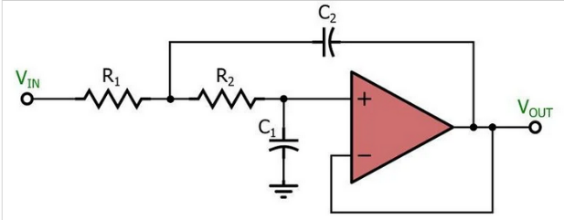

**Project Tracking** (current work): Assignments and activities are to be tracked until completed.

|  |  |  |  |
| --- | --- | --- | --- |
| Team Member | Assignment | Due Date | % Complete |
| Cody White (Float) | BLDC characteristics research | 1 Oct 2021 | 75 |
| Ayham Sabra (Lead) | Testing criteria for the specific DO regs | 1 Oct 2021 | 50 |
| Mel St.John (Scribe) | Control circuit research | 1 Oct 2021 | 75 |
| Cody White (Float) | Finish contributions to planning paper | 26 Sept 2021 | 100 |
| Ayham Sabra (Lead) | Contact Textron with questions and inquire into the motor they were providing so we don’t have to wait for it when we are ready for it.  Also, inquire into the DO regs that we can’t seem to get access to. | 27 Sept 2021 | 0 |
| Mel St.John (Scribe) | Finish formatting the planning document and type of the meeting minutes. | 26 Sept 2021 | 100 |
| All members | Start calculating specific values for our preliminary circuits. | 29 Sept 2021 |  |

Plan (future work):

This week the majority of the members’ time was spent on paperwork for the SD class assignments that were due and the further research into he specific circuits needed for this project. The next week will be spent doing further research and deciding on specific component values for each part of the circuit in order to start our first simulations. We will also begin to familiarize ourselves with LTspice.

|  |  |
| --- | --- |
| Assignment | Due Date |
| BLDC Characteristics Research (Cody White) | 1 Oct 2021 |
| Research testing criteria required by DO regs (Ayham Sabra) | 1 Oct 2021 |
| Research control circuits and form a preliminary design plan (Mel St.John) | 1 Oct 2021 |
| All members are to familiarize themselves with LTspice | On-going |
| All members start calculating values for our preliminary circuits | 29 Sept 2021 |
|  |  |
|  |  |
|  |  |
|  |  |
|  |  |
|  |  |
|  |  |
|  |  |

Issues:

No issues have arisen currently.

Include the schedule for the next meeting:

Meeting Date & Time: 24 Sept 2021, 15:30, Team meeting to go over research findings and solidify our ‘more

functional’ block diagram.

26 Sept 2021, 17:30, Dr. Ara to make sure we are on the right track.

Meeting Location: Library WSU

John Bardo lobby TTB

Team Name: **Electron Wranglers**

# Date of Submission: 03 Oct 2021

Meeting Date & Time: 03 Oct 2021 16:30

06 Oct 2021 09:30

Meeting Location John Bardo ( 10 Oct 2021)

Online (06 Oct 2021)

Meeting Duration: 1.5 hrs.

1.5 hrs.

## Team Attendance

|  |  |  |
| --- | --- | --- |
| Team Members | X = Present | Notes |
| Melvin St.John | X |  |
| Ayham Sabra | X |  |
| Cody White | X |  |
| Dr. Ara |  |  |
| Arun |  |  |

### Progress:

**Individual contributions:**

**Mtg. (03 Oct 2021: Testing on the provided fan**

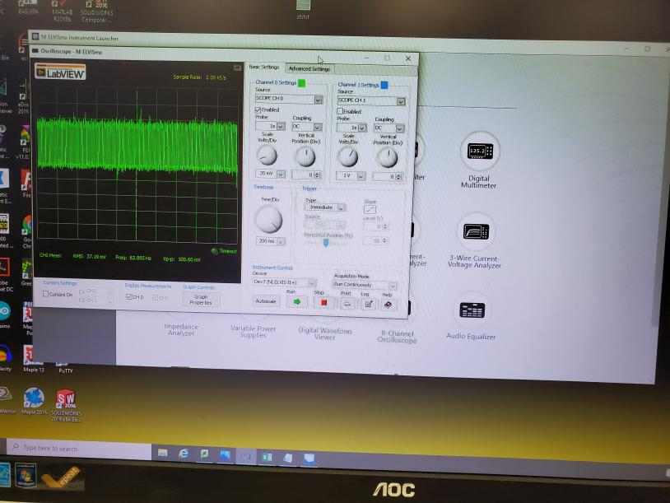 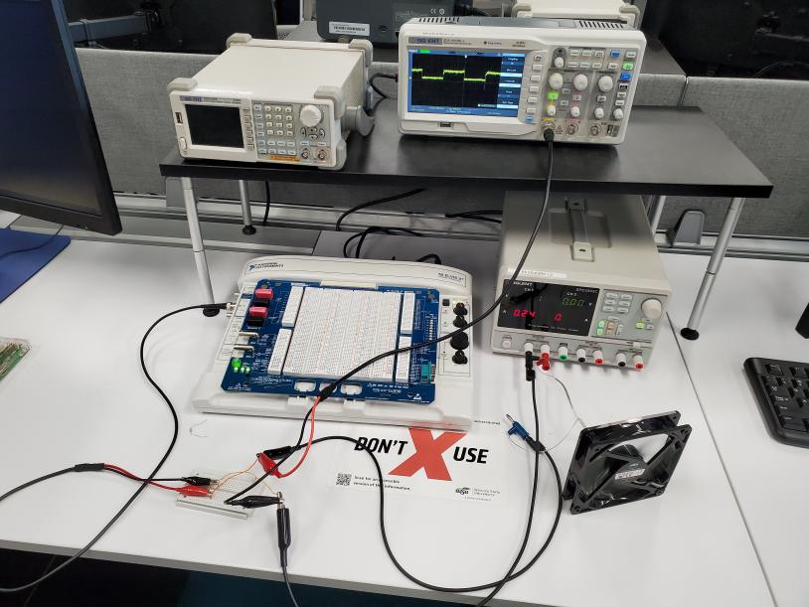

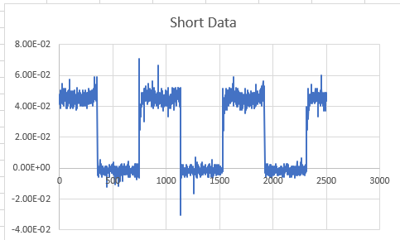 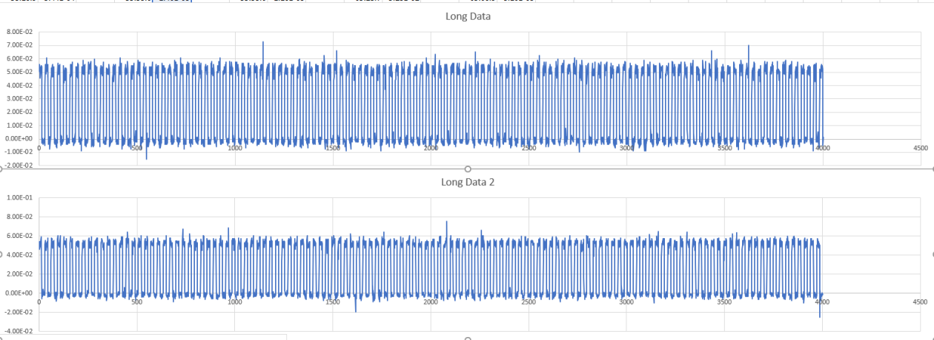

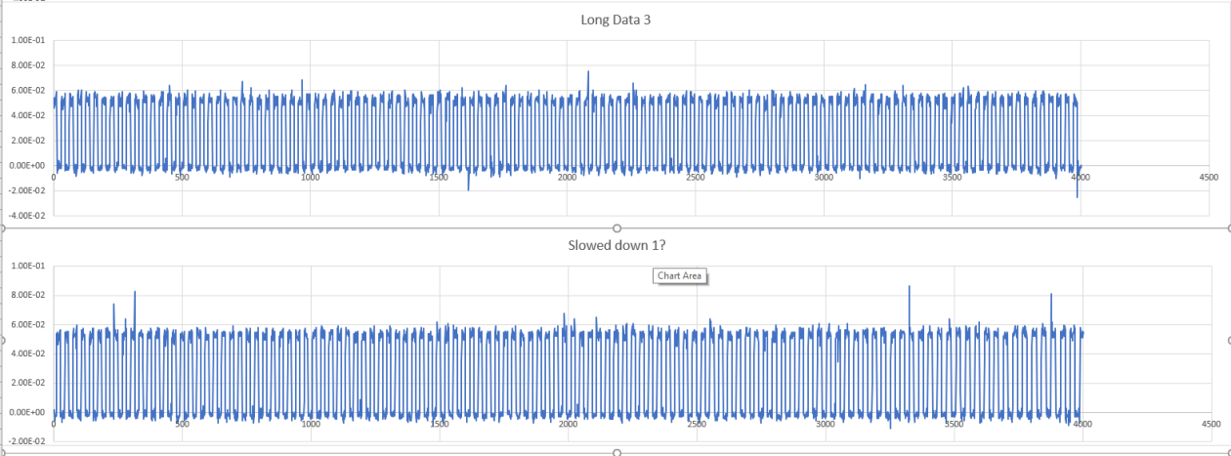

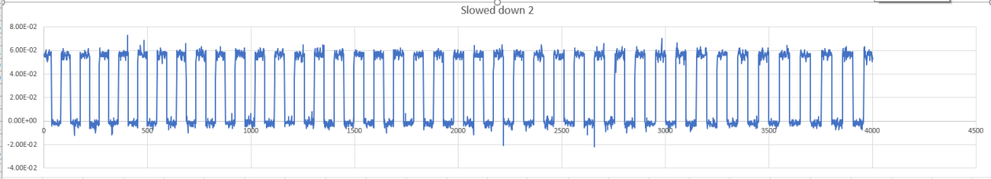

**Mtg. (06 Oct 2021): Prep for Midterm.**

**Went over slides and did multiple test runs of our speech.**

**Project Tracking** (current work): Assignments and activities are to be tracked until completed.

|  |  |  |  |
| --- | --- | --- | --- |
| Team Member | Assignment | Due Date | % Complete |
| Cody White (Float) | BLDC characteristics research | 1 Oct 2021 | 100 |
| Ayham Sabra (Lead) | Testing criteria for the specific DO regs | 1 Oct 2021 | 80, pending info from Clinton |
| Mel St.John (Scribe) | Control circuit research | 1 Oct 2021 | 85 |
| Cody White (Float) | Finish contributions to planning paper | 26 Sept 2021 | 100 |
| Ayham Sabra (Lead) | Contact Textron with questions and inquire into the motor they were providing so we don’t have to wait for it when we are ready for it.  Also, inquire into the DO regs that we can’t seem to get access to. | 27 Sept 2021 | 100 |
| Mel St.John (Scribe) | Finish formatting the planning document and type of the meeting minutes. | 26 Sept 2021 | 100 |
| All members | Start calculating specific values for our preliminary circuits. | 29 Sept 2021  Ext. to 15 Oct | 75 |
| All members | Filter circuits and voltage regulator circuits | 15 Oct 2021 | 60 |
| All members | All members are to familiarize themselves with LTspice | On-going | 40 |

Plan (future work):

This week the majority of the members’ time was spent on paperwork for the SD class assignments that were due and the further research into the specific circuits needed for this project. The next week will be spent, predominately preparing for the midterm. Additionally, as time allows, we will be doing further research and deciding on the specific component values for each part of the circuit in order to start our first simulations. We will also continue to familiarize ourselves with LTspice.

|  |  |
| --- | --- |
| Assignment | Due Date |
| Further study into open-collector outputs (all members) | 15 Oct 2021 |
| Further study into filters and voltage regulators (all members) | 15 Oct 2021 |
| Power the fan and record the output waveform and readings (all members) | 03 Oct 2021 |
| All members are to familiarize themselves with LTspice | On-going |
|  |  |
|  |  |
|  |  |
|  |  |
|  |  |
|  |  |
|  |  |
|  |  |
|  |  |

Issues:

No issues have arisen currently.

Include the schedule for the next meeting:

Meeting Date & Time: 03 Oct 2021, 16:00, Team (with Dr. Ara) to test the fan and record the waveform.

06 Oct 2021, 17:30, Team to work on midterm.

Meeting Location: John Bardo Lab (03 Oct)

Online (06 Oct)

Team Name: **Electron Wranglers**

# Date of Submission: 17 Oct 2021

Meeting Date & Time: 03 Oct 2021 16:30

06 Oct 2021 19:30

15 Oct 2021 10:45

Meeting Location John Bardo ( 10 Oct 2021)

Online (06 Oct 2021)

John Bardo Lab (15 Oct.)

Meeting Duration: 1.0 hrs.

1.5 hrs.

2.0 hrs.

## Meeting Attendance

|  |  |  |
| --- | --- | --- |
| Team Members | X = Present | Notes |
| Melvin St.John | X |  |
| Ayham Sabra | X |  |
| Cody White | X |  |
| Dr. Ara |  |  |
| Arun |  |  |

### Progress:

**Individual contributions:**

**Mtg. (03 Oct 2021: Testing on the provided fan**

 

 





**Mtg. (06 Oct 2021): Prep for Midterm.**

Went over slides and did multiple test runs of our midterm presentation.

**Mtg. (15 Oct 2021): Continued testing on tach output.**

We tried to implement a filter after the tach. To reduce some of the noise. We did not get the expected results. Our wave seemed to oscillate rather than remove noise, which has us confused.

**Project Tracking** (current work): Assignments and activities are to be tracked until completed.

|  |  |  |  |
| --- | --- | --- | --- |
| Team Member | Assignment | Due Date | % Complete |
| Cody White (Float) | BLDC characteristics research | 1 Oct 2021 | 100 |
| Ayham Sabra (Lead) | Testing criteria for the specific DO regs | 1 Oct 2021 | 80, pending info from Clinton |
| Mel St.John (Scribe) | Control circuit research | 1 Oct 2021 | 85 |
| Cody White (Float) | Finish contributions to planning paper | 26 Sept 2021 | 100 |
| Ayham Sabra (Lead) | Contact Textron with questions and inquire into the motor they were providing so we don’t have to wait for it when we are ready for it.  Also, inquire into the DO regs that we can’t seem to get access to. | 27 Sept 2021 | 100 |
| Mel St.John (Scribe) | Finish formatting the planning document and type of the meeting minutes. | 26 Sept 2021 | 100 |
| All members | Start calculating specific values for our preliminary circuits. | 29 Sept 2021  Ext. to 22 Oct | 75 |
| All members | Filter circuits and voltage regulator circuits | 22 Oct 2021 | 60 |
| All members | All members are to familiarize themselves with LTspice | On-going | 40 |

Plan (future work):

This week the majority of the members’ time was spent on paperwork for the SD class assignments that were due and the further research into the specific circuits needed for this project. The next week will be spent, predominately preparing for the midterm. Additionally, as time allows, we will be doing further research and deciding on the specific component values for each part of the circuit in order to start our first simulations. We will also continue to familiarize ourselves with LTspice.

|  |  |
| --- | --- |
| Assignment | Due Date |
| Further study into open-collector outputs (all members) | 15 Oct 2021 |
| Further study into filters and voltage regulators (all members) | 15 Oct 2021 |
| Power the fan and record the output waveform and readings (all members) | 03 Oct 2021 |
| All members are to familiarize themselves with LTspice | On-going |
|  |  |
|  |  |
|  |  |
|  |  |
|  |  |
|  |  |
|  |  |
|  |  |
|  |  |

Issues:

No issues have arisen currently.

Include the schedule for the next meeting:

Meeting Date & Time: 03 Oct 2021, 16:00, Team (with Dr. Ara) to test the fan and record the waveform.

06 Oct 2021, 17:30, Team to work on midterm.

Meeting Location: John Bardo Lab (03 Oct)

Online (06 Oct)

Team Name: **Electron Wranglers**

# Date of Submission: 24 Oct 2021

Meeting Date & Time: 17 Oct 2021 16:30

22 Oct 2021 19:30

Meeting Location John Bardo ( 17 Oct 2021)

Online (22 Oct 2021)

Meeting Duration: 0.75 hrs.

2.0 hrs.

.  
Meeting Attendance

|  |  |  |
| --- | --- | --- |
| Team Members | X = Present | Notes |
| Melvin St.John | X | 17 Oct and 22 Oct |
| Ayham Sabra | X | 17 Oct and 22 Oct |
| Cody White | X | 17 Oct and 22 Oct |
| Dr. Ara | x | 17 Oct |
| Arun | x | 17 Oct |

### Progress:

**Individual contributions:**

**Mtg. (17 Oct 2021: Meeting with Dr. Ara to discuss questions, etc.**

We discussed with Dr. Ara our problems with getting correct readings when implementing a filter circuit on the breadboard. We discussed the possible need for an integrator to be incorporated as well as the details of doing a Fourier analysis, Bode Plot, etc. Ayham will look into the Fourier analysis, Mel is looking into more details on the RC filter, and Cody is looking more into the integrator circuit.

**Mtg. (22 Oct 2021): Preparing the Technical Product Specifications paper.**

We met online to write the Tech. Prod. Spec. Paper together.

**Project Tracking** (current work): Assignments and activities are to be tracked until completed.

|  |  |  |  |
| --- | --- | --- | --- |
| Team Member | Assignment | Due Date | % Complete |
| Cody White (Float) | BLDC characteristics research | 1 Oct 2021 | 100 |
| Ayham Sabra (Lead) | Testing criteria for the specific DO regs | 1 Oct 2021 | 80, pending info from Clinton |
| Mel St.John (Scribe) | Control circuit research | 1 Oct 2021 | 85 |
| Cody White (Float) | Finish contributions to planning paper | 26 Sept 2021 | 100 |
| Ayham Sabra (Lead) | Contact Textron with questions and inquire into the motor they were providing so we don’t have to wait for it when we are ready for it.  Also, inquire into the DO regs that we can’t seem to get access to. | 27 Sept 2021 | 100 |
| Mel St.John (Scribe) | Finish formatting the planning document and type of the meeting minutes. | 26 Sept 2021 | 100 |
| All members | Start calculating specific values for our preliminary circuits. | 29 Sept 2021  Ext. to 22 Oct | 75 |
| All members | Filter circuits and voltage regulator circuits | 22 Oct 2021 | 60 |
| All members | All members are to familiarize themselves with LTspice | On-going | 40 |

Plan (future work):

This week the majority of the members’ time was spent on paperwork for the SD class assignments that were due and the further research into the specific circuits needed for this project. The next week will be spent, predominately preparing for the midterm. Additionally, as time allows, we will be doing further research and deciding on the specific component values for each part of the circuit in order to start our first simulations. We will also continue to familiarize ourselves with LTspice.

|  |  |
| --- | --- |
| Assignment | Due Date |
| Further study into open-collector outputs (all members) | 15 Oct 2021 |
| Further study into filters and voltage regulators (all members) | 15 Oct 2021 |
| Power the fan and record the output waveform and readings (all members) | 03 Oct 2021 |
| All members are to familiarize themselves with LTspice | On-going |
| Looking into the Fourier analysis (Ayham) | 24 Oct 2021 |
| Further refining on the RC filter (Mel) | 24 Oct 2021 |
| Researching Integrator (Cody) | 24 Oct 2021 |
|  |  |
|  |  |
|  |  |
|  |  |
|  |  |
|  |  |

Issues:

No issues have arisen currently.

Include the schedule for the next meeting:

Meeting Date & Time: 24 Oct 2021, 16:00, Team (with Dr. Ara)

TBD

Meeting Location: John Bardo Lab (24 Oct)

Online TBD

Team Name: **Electron Wranglers**

# Date of Submission: 31 Oct 2021

Meeting Date & Time: 24 Sept 2021 12:00

26 Sept 2021 15:00

Meeting Location RSC (outside)

Online (09 Sept 2021)

Meeting Duration: 1.25 hrs.

1.5 hrs.

## Meeting Attendance

|  |  |  |
| --- | --- | --- |
| Team Members | X = Present | Notes |
| Melvin St.John | X |  |
| Ayham Sabra | X |  |
| Cody White | X |  |
|  |  |  |
|  |  |  |

### Progress:

**Individual contributions:**

Mtg. (24 Sept 2021): We discussed the planning document that is due on 9/26 Mel had started it prior to the meeting. Ayham and Cody gave additional information to be included before the due date and made suggestions about the formatting, etc.

We discussed the filter circuit. Specifically, the type of circuit and components to be used. I believe the consensus reached was to start off with a simple RC series filter and adjust later if the need arises.

We discussed the various types of voltage regulator circuits. We believe that we need this to regulate the bus voltage so that we have a stable reference voltage for our comparator circuit. We also discussed the placement of the VR within our circuit design and why.

We agreed to meet again on our discord server on 26 Sept to finalize the project planning paper and discuss any new suggestions that our research has brought to mind.

Mtg. (26 Sept 2021):

We discussed two different versions of the comparator circuits and a filter. Mel provided a starting point circuit that incorporates hysteresis. Ayham provided another version for comparison. It was decided the larger the larger circuit would become too large for our project when the VR and Filter circuitry was incorporated.

The two circuits discussed:

**Project Tracking** (current work): Assignments and activities are to be tracked until completed.

|  |  |  |  |
| --- | --- | --- | --- |
| Team Member | Assignment | Due Date | % Complete |
| Cody White (Float) | BLDC characteristics research | 1 Oct 2021 | 75 |
| Ayham Sabra (Lead) | Testing criteria for the specific DO regs | 1 Oct 2021 | 50 |
| Mel St.John (Scribe) | Control circuit research | 1 Oct 2021 | 75 |
| Cody White (Float) | Finish contributions to planning paper | 26 Sept 2021 | 100 |
| Ayham Sabra (Lead) | Contact Textron with questions and inquire into the motor they were providing so we don’t have to wait for it when we are ready for it.  Also, inquire into the DO regs that we can’t seem to get access to. | 27 Sept 2021 | 0 |
| Mel St.John (Scribe) | Finish formatting the planning document and type of the meeting minutes. | 26 Sept 2021 | 100 |
| All members | Start calculating specific values for our preliminary circuits. | 29 Sept 2021 |  |

Plan (future work):

This week the majority of the members’ time was spent on paperwork for the SD class assignments that were due and the further research into he specific circuits needed for this project. The next week will be spent doing further research and deciding on specific component values for each part of the circuit in order to start our first simulations. We will also begin to familiarize ourselves with LTspice.

|  |  |
| --- | --- |
| Assignment | Due Date |
| BLDC Characteristics Research (Cody White) | 1 Oct 2021 |
| Research testing criteria required by DO regs (Ayham Sabra) | 1 Oct 2021 |
| Research control circuits and form a preliminary design plan (Mel St.John) | 1 Oct 2021 |
| All members are to familiarize themselves with LTspice | On-going |
| All members start calculating values for our preliminary circuits | 29 Sept 2021 |
|  |  |
|  |  |
|  |  |
|  |  |
|  |  |
|  |  |
|  |  |
|  |  |

Issues:

No issues have arisen currently.

Include the schedule for the next meeting:

Meeting Date & Time: 24 Sept 2021, 15:30, Team meeting to go over research findings and solidify our ‘more

functional’ block diagram.

26 Sept 2021, 17:30, Dr. Ara to make sure we are on the right track.

Meeting Location: Library WSU

John Bardo lobby TTBD

Team Name: **Electron Wranglers**

# Date of Submission: 14 Nov 2021

Meeting Date & Time:

06 Nov 2021 15:30 Dr. Ara

07 Nov 2021 16:30 Team

08 Nov 2021 10:30 Team

10 Nov 2021 10:30 Team

12 Nov 2021 10:30 Team

Meeting Location: John Bardo ( 06 Nov 2021)

07 Nov 2021 15:30 Online

08 Nov 2021 19:30 Online

10 Nov 2021 13:30 Online

12 Nov 2021 11:30 Campus Library

Meeting Duration: 1.0 hrs.

2.0 hrs.

2.0 hrs.

1.75 hrs.

1.5 hrs.

## Meeting Attendance

|  |  |  |
| --- | --- | --- |
| Team Members | X = Present | Notes |
| Melvin St.John | X | 06,07,08,10,12 Nov |
| Ayham Sabra | X | 06,07,08,10,12 Nov |
| Cody White | X | 06,07,08,10,12 Nov |
| Dr. Ara | x | 06 Nov |
| Arun | x | 06 Nov |

### Progress:

**Individual contributions:**

**Mtg. (6 Nov 2021: Meeting with Dr. Ara to discuss questions, etc.**

This meeting mostly dealt with Ayham and the Fourier analysis. We sent over the integrator and discussed the filter. We need to convert to a dc signal before the comparator.

**Mtg. (6 Nov 2021): Discussing the different interviews and starting Reflection Paper**

**Mtg. (7 Nov 2021): Discussions on the Reflection Paper and finishing the assignment. Also, went over equations for the filter and integrator (for ideal signal) because our simulations are not providing the expected results.**

**Mtg. (10 Nov 2021): Misc. Discussion**

Discussed buying oscilloscope and power supply.

Discussed research topics concerning the integrator design and different operations that would be suitable for our frequency requirements (the Rc constant). We also discussed doing away with the integrator in favor of other design options.

We discussed a frequency type circuit like the instrument amp circuit.

We discussed the need to either get an order in for some components to test with during fall break or ask about whether our budget can be transferred to next and have both in one period.

Still haven’t gotten a response from Clinton at Textron (via email). If we don’t hear back by Friday, we will call the number he provided.

We discussed how the differing opinions between ‘mentor’ has us feeling confused on some aspects. Hence, the email to Clinton.

Mel discussed that he was exposed to a Covid positive person. He is not feeling poorly but wanted to notify and get everyone’s opinion in regard to the Friday meeting.

**Mtg. (12 Nov 2021): General Discussion**

We discussed the video for the Fall Showcase: Who has a cam/tripod, did we want to do it separately, or together. we will meet Sunday, the 21st to film it together rather than piecing it together.

Discussed what components/parts we needed to get ordered and where to source them.

Asked Ayham if he had gotten a response from Clinton yet concerning meeting with him. It is set for the 24th at 1300. Mel gave notice that he would have to zoom in for that one as he will be out of state that day.

We discussed calculation results for our integrator and comparator design. We refigured some to account for various frequencies and simulated approximately 8 different trials. Progress is being made. The consensus was that we are fairly happy with the integrator, but the comparator needs more tweaking.

**Project Tracking** (current work): Assignments and activities are to be tracked until completed.

|  |  |  |  |
| --- | --- | --- | --- |
| Team Member | Assignment | Due Date | % Complete |
| Cody White (Float) | BLDC characteristics research | 1 Oct 2021 | 100 |
| Ayham Sabra (Lead) | Testing criteria for the specific DO regs | 1 Oct 2021 | 80, pending info from Clinton |
| Mel St.John (Scribe) | Control circuit research | 1 Oct 2021 | 85 |
| Cody White (Float) | Finish contributions to planning paper | 26 Sept 2021 | 100 |
| Ayham Sabra (Lead) | Contact Textron with questions and inquire into the motor they were providing so we don’t have to wait for it when we are ready for it.  Also, inquire into the DO regs that we can’t seem to get access to. | 27 Sept 2021 | 100 |
| Mel St.John (Scribe) | Finish formatting the planning document and type of the meeting minutes. | 26 Sept 2021 | 100 |
| All members | Start calculating specific values for our preliminary circuits. | 29 Sept 2021  Ext. to 22 Oct | 75 |
| All members | Filter circuits and voltage regulator circuits | 22 Oct 2021 | 60 |
| All members | All members are to familiarize themselves with LTspice | On-going | 80 |

Plan (future work):

We will be working more on the comparator component values to accommodate changes that we made to the integrator. We hope to have it nailed down a littles closer by the time we meet Dr. Ara again on Sunday the 14th.

|  |  |
| --- | --- |
| Assignment | Due Date |
| Further study into open-collector outputs (all members) | 15 Oct 2021/ on- going |
| Further study into filters and voltage regulators (all members) | 15 Oct 2021 |
| Power the fan and record the output waveform and readings (all members) | 03 Oct 2021 |
| All members are to familiarize themselves with LTspice | On-going |
| Looking into the Fourier analysis (Ayham) | 24 Oct 2021 |
| Further refining on the RC filter (Mel) | 24 Oct 2021 |
| Researching Integrator (Cody) | 24 Oct 2021 |
|  |  |
|  |  |
|  |  |
|  |  |
|  |  |
|  |  |

Issues:

No issues have arisen currently.

Include the schedule for the next meeting:

Meeting Date & Time 12 Nov 2021, 16:00, Team (with Dr. Ara) cancelled-Dr. Ara unavailable

Meeting Location: John Bardo Lab (Nov TBD)

Others TBD

# ECE 595 Spring Semester 2022

Team Name: **Electron Wranglers**

# Date of Submission: 06 February 2022

Meeting Date & Time- 23 January 2022 @1700

Meeting Location Teams

Meeting Duration: 42m 32s

## Meeting Attendance

|  |  |  |
| --- | --- | --- |
| Team Members | X = Present | Notes |
| Melvin St.John | X |  |
| Ayham Sabra | X |  |
| Cody White | X |  |
| Dr. Ara |  |  |
| Arun |  |  |

### Progress:

**Individual contributions:**

This was the first meeting since the fall break. The team went over where we were at on the project up to this point, and what needed to be done next. We passed out some assignments between us which are listed below.

We composed an email to Textron to inform them of our current status on the project and inquire about whether they had specific libraries that they used for their Altium program.

I have attached the transcript below of the Teams meeting.



**Project Tracking** (current work): Assignments and activities are to be tracked until completed.

|  |  |  |  |
| --- | --- | --- | --- |
| Team Member | Assignment | Due Date | % Complete |
| Cody White (Float) | Voltage regulator and TVS | 2-6-22 | 75 |
| Ayham Sabra (Lead) | Component values on 555  Output circuit (MOSFETs) | 2-6-22  2-6-22 | 90 |
| Mel St.John (Scribe) | Start inputting circuit into Altium software | On-going | 30 |
|  |  |  |  |
|  |  |  |  |
|  |  |  |  |
| All members |  |  |  |
| All members |  |  |  |
| All members |  |  |  |

Plan (future work):

1. Finalize the component values of entire circuit
2. Forward to Textron
3. Enter full circuit into Altium (PCB design)

|  |  |
| --- | --- |
| Assignment | Due Date |
|  |  |
|  |  |
|  |  |
|  |  |
|  |  |
|  |  |
|  |  |
|  |  |
|  |  |
|  |  |
|  |  |
|  |  |
|  |  |

Issues:

No issues have arisen currently.

Include the schedule for the next meeting:

Meeting Date & Time 28 January 2022 @1700

Meeting Location: Teams

Team Name: **Electron Wranglers**

# Date of Submission: 06 February 2022

Meeting Date & Time- 23 January 2022 @1700

Meeting Location Teams

Meeting Duration: 52m 15s

## Meeting Attendance

|  |  |  |
| --- | --- | --- |
| Team Members | X = Present | Notes |
| Melvin St.John | X |  |
| Ayham Sabra | X |  |
| Cody White | X |  |
| Dr. Ara |  |  |
| Arun |  |  |

### Progress:

**Individual contributions:**

We began the meeting with discussing MOFSETS. We all three discussed it and Cody and Mel gave insights and opinions to Ayham on these components (i.e., the differences between bjt and mofsets, like one operates on current, the other voltage, etc.).

Cody then brought up his questions concerning the voltage regulator. We have decided to use a ‘off the shelf’ voltage regulating after discussing it and asking Textron. Cody will be finding it for us and the TVs as well.

I apologize (this is Mel). I put the composition of the email to Textron in the previous meeting and it occurred during this meeting.

We also discussed the need to alter our current design to accommodate a 5v fan, as was assigned, rather than for the 12v fan that we were provided. We discussed the change in component values, specifically, the comparator so that it would be more appropriate. It now operates at 5.5v and we need to adjust it to switch at approximately 2.4v for a 5v system.

Cody will also begin doing calculations with reference to the heat dissipation of the circuit to decide whether there’s a need for a heat sink, etc.

We also, collectively, will begin looking into materials appropriate for the enclosure for the circuit. Depending on the need; Cody, and Mel both have experience with Catia if it’s need.

I am attaching the Teams transcript below.



**Project Tracking** (current work): Assignments and activities are to be tracked until completed.

|  |  |  |  |
| --- | --- | --- | --- |
| Team Member | Assignment | Due Date | % Complete |
| Cody White (Float) | Voltage regulator and TVS |  |  |
| Ayham Sabra (Lead) | Component values on 555  Output circuit (MOSFETs) |  |  |
| Mel St.John (Scribe) | Start inputting circuit into Altium software |  |  |
|  |  |  |  |
|  |  |  |  |
|  |  |  |  |
| All members |  |  |  |
| All members |  |  |  |
| All members |  |  |  |

Plan (future work):

|  |  |
| --- | --- |
| Assignment | Due Date |
|  |  |
|  |  |
|  |  |
|  |  |
|  |  |
|  |  |
|  |  |
|  |  |
|  |  |
|  |  |
|  |  |
|  |  |
|  |  |

Issues:

No issues have arisen currently.

Include the schedule for the next meeting:

Meeting Date & Time 04 February 2022 @1700

Meeting Location: Teams

Team Name: **Electron Wranglers**

# Date of Submission: 20 February 2022

Meeting Date & Time- 04 February 2022 @1700

18 February 2022 @1700

Meeting Location Teams

Meeting Duration: 1.5 hrs.

## Meeting Attendance

|  |  |  |
| --- | --- | --- |
| Team Members | X = Present | Notes |
| Melvin St.John | X |  |
| Ayham Sabra | X |  |
| Cody White | X |  |
|  |  |  |
|  |  |  |

### Progress:

**Individual contributions:**

**04 Feb 2022 Meeting:**

 

Team discussed and finished the updated work statement. We discussed the voltage regulator and Cody has found an off the shelf one and he has located the TVs. We reviewed data sheets concerning the above items. We discussed the process that LtSpice has to figure power and heat values for differing components. We discussed the voltage divider for reference voltage to comparator as well as the current sink portion of the circuit.

**18 Feb 2022 meeting**:

Unfortunately, there was a mishap with the transcript from Teams. It didn’t come through. I have attempted to reconstruct the gist of the meeting below:

Cody detailed his progress with regard to the temperature and power calculations. I (Mel) discussed my current progress on Altium as well as packaging requirements that the military have, i.e., aluminum shielding for clocking circuit, etc.. Ayham discussed packaging and his thoughts about carbon fiber, PTFE, and other materials. He also discussed the FAA/FAR regulation with regard to fire tests. We all discussed the output state (MOSFETs) but predominantly it was Ayham.

**Project Tracking** (current work): Assignments and activities are to be tracked until completed.

|  |  |  |  |
| --- | --- | --- | --- |
| Team Member | Assignment | Due Date | % Complete |
| Cody White (Float) | Voltage regulator and TVS |  | 100 |
| Ayham Sabra (Lead) | Component values on 555  Output circuit (MOSFETs) |  | 85 |
| Mel St.John (Scribe) | Start inputting circuit into Altium software |  | 25 |
| Cody White (Float) | Thermal studies |  | 25 |
| Ayham Sabra (Lead) | Github |  | 50 |
| Mel St.John (Scribe) |  |  |  |
| All members |  |  |  |
| All members |  |  |  |
| All members |  |  |  |

Plan (future work):

|  |  |
| --- | --- |
| Assignment | Due Date |
|  |  |
|  |  |
|  |  |
|  |  |
|  |  |
|  |  |
|  |  |
|  |  |
|  |  |
|  |  |
|  |  |
|  |  |
|  |  |

Issues:

No issues have arisen currently.

Include the schedule for the next meeting:

Meeting Date & Time: Wednesday, 23 Feb 2022 (Textron)

Friday, 25 Feb 2022 (team)

Meeting Location: Teams, Teams

Team Name: **Electron Wranglers**

# Date of Submission: 20 February 2022

Meeting Date & Time-

Meeting Location

Meeting Duration:

## Meeting Attendance

|  |  |  |
| --- | --- | --- |
| Team Members | X = Present | Notes |
| Melvin St.John | X |  |
| Ayham Sabra | X |  |
| Cody White | X |  |
|  |  |  |
|  |  |  |

### Progress:

**Individual contributions:**

**Project Tracking** (current work): Assignments and activities are to be tracked until completed.

|  |  |  |  |
| --- | --- | --- | --- |
| Team Member | Assignment | Due Date | % Complete |
| Cody White (Float) |  |  |  |
| Ayham Sabra (Lead) |  |  |  |
| Mel St.John (Scribe) |  |  |  |
| Cody White (Float) |  |  |  |
| Ayham Sabra (Lead) |  |  |  |
| Mel St.John (Scribe) |  |  |  |
| All members |  |  |  |
| All members |  |  |  |
| All members |  |  |  |

Plan (future work):

|  |  |
| --- | --- |
| Assignment | Due Date |
|  |  |
|  |  |
|  |  |
|  |  |
|  |  |
|  |  |
|  |  |
|  |  |
|  |  |
|  |  |
|  |  |
|  |  |
|  |  |

Issues:

No issues have arisen currently.

Include the schedule for the next meeting:

Meeting Date & Time

Meeting Location:

Team Name: **Electron Wranglers**

# Date of Submission:

Meeting Date & Time-

Meeting Location

Meeting Duration:

## Meeting Attendance

|  |  |  |
| --- | --- | --- |
| Team Members | X = Present | Notes |
| Melvin St.John | X |  |
| Ayham Sabra | X |  |
| Cody White | X |  |
| Dr. Ara | x |  |
| Arun | x |  |

### Progress:

**Individual contributions:**

**Project Tracking** (current work): Assignments and activities are to be tracked until completed.

|  |  |  |  |
| --- | --- | --- | --- |
| Team Member | Assignment | Due Date | % Complete |
| Cody White (Float) |  |  |  |
| Ayham Sabra (Lead) |  |  |  |
| Mel St.John (Scribe) |  |  |  |
| Cody White (Float) |  |  |  |
| Ayham Sabra (Lead) |  |  |  |
| Mel St.John (Scribe) |  |  |  |
| All members |  |  |  |
| All members |  |  |  |
| All members |  |  |  |

Plan (future work):

|  |  |
| --- | --- |
| Assignment | Due Date |
|  |  |
|  |  |
|  |  |
|  |  |
|  |  |
|  |  |
|  |  |
|  |  |
|  |  |
|  |  |
|  |  |
|  |  |
|  |  |

Issues:

No issues have arisen currently.

Include the schedule for the next meeting:

Meeting Date & Time

Meeting Location:

Team Name: **Electron Wranglers**

# Date of Submission:

Meeting Date & Time-

Meeting Location

Meeting Duration:

## Meeting Attendance

|  |  |  |
| --- | --- | --- |
| Team Members | X = Present | Notes |
| Melvin St.John | X |  |
| Ayham Sabra | X |  |
| Cody White | X |  |
| Dr. Ara | x |  |
| Arun | x |  |

### Progress:

**Individual contributions:**

**Project Tracking** (current work): Assignments and activities are to be tracked until completed.

|  |  |  |  |
| --- | --- | --- | --- |
| Team Member | Assignment | Due Date | % Complete |
| Cody White (Float) |  |  |  |
| Ayham Sabra (Lead) |  |  |  |
| Mel St.John (Scribe) |  |  |  |
| Cody White (Float) |  |  |  |
| Ayham Sabra (Lead) |  |  |  |
| Mel St.John (Scribe) |  |  |  |
| All members |  |  |  |
| All members |  |  |  |
| All members |  |  |  |

Plan (future work):

|  |  |
| --- | --- |
| Assignment | Due Date |
|  |  |
|  |  |
|  |  |
|  |  |
|  |  |
|  |  |
|  |  |
|  |  |
|  |  |
|  |  |
|  |  |
|  |  |
|  |  |

Issues:

No issues have arisen currently.

Include the schedule for the next meeting:

Meeting Date & Time

Meeting Location:

Team Name: **Electron Wranglers**

# Date of Submission:

Meeting Date & Time-

Meeting Location

Meeting Duration:

## Meeting Attendance

|  |  |  |
| --- | --- | --- |
| Team Members | X = Present | Notes |
| Melvin St.John | X |  |
| Ayham Sabra | X |  |
| Cody White | X |  |
| Dr. Ara | x |  |
| Arun | x |  |

### Progress:

**Individual contributions:**

**Project Tracking** (current work): Assignments and activities are to be tracked until completed.

|  |  |  |  |
| --- | --- | --- | --- |
| Team Member | Assignment | Due Date | % Complete |
| Cody White (Float) |  |  |  |
| Ayham Sabra (Lead) |  |  |  |
| Mel St.John (Scribe) |  |  |  |
| Cody White (Float) |  |  |  |
| Ayham Sabra (Lead) |  |  |  |
| Mel St.John (Scribe) |  |  |  |
| All members |  |  |  |
| All members |  |  |  |
| All members |  |  |  |

Plan (future work):

|  |  |
| --- | --- |
| Assignment | Due Date |
|  |  |
|  |  |
|  |  |
|  |  |
|  |  |
|  |  |
|  |  |
|  |  |
|  |  |
|  |  |
|  |  |
|  |  |
|  |  |

Issues:

No issues have arisen currently.

Include the schedule for the next meeting:

Meeting Date & Time

Meeting Location:

Team Name: **Electron Wranglers**

# Date of Submission:

Meeting Date & Time-

Meeting Location

Meeting Duration:

## Meeting Attendance

|  |  |  |
| --- | --- | --- |
| Team Members | X = Present | Notes |
| Melvin St.John | X |  |
| Ayham Sabra | X |  |
| Cody White | X |  |
| Dr. Ara | x |  |
| Arun | x |  |

### Progress:

**Individual contributions:**

**Project Tracking** (current work): Assignments and activities are to be tracked until completed.

|  |  |  |  |
| --- | --- | --- | --- |
| Team Member | Assignment | Due Date | % Complete |
| Cody White (Float) |  |  |  |
| Ayham Sabra (Lead) |  |  |  |
| Mel St.John (Scribe) |  |  |  |
| Cody White (Float) |  |  |  |
| Ayham Sabra (Lead) |  |  |  |
| Mel St.John (Scribe) |  |  |  |
| All members |  |  |  |
| All members |  |  |  |
| All members |  |  |  |

Plan (future work):

|  |  |
| --- | --- |
| Assignment | Due Date |
|  |  |
|  |  |
|  |  |
|  |  |
|  |  |
|  |  |
|  |  |
|  |  |
|  |  |
|  |  |
|  |  |
|  |  |
|  |  |

Issues:

No issues have arisen currently.

Include the schedule for the next meeting:

Meeting Date & Time

Meeting Location:

Team Name: **Electron Wranglers**

# Date of Submission:

Meeting Date & Time-

Meeting Location

Meeting Duration:

## Meeting Attendance

|  |  |  |
| --- | --- | --- |
| Team Members | X = Present | Notes |
| Melvin St.John | X |  |
| Ayham Sabra | X |  |
| Cody White | X |  |
| Dr. Ara | x |  |
| Arun | x |  |

### Progress:

**Individual contributions:**

**Project Tracking** (current work): Assignments and activities are to be tracked until completed.

|  |  |  |  |
| --- | --- | --- | --- |
| Team Member | Assignment | Due Date | % Complete |
| Cody White (Float) |  |  |  |
| Ayham Sabra (Lead) |  |  |  |
| Mel St.John (Scribe) |  |  |  |
| Cody White (Float) |  |  |  |
| Ayham Sabra (Lead) |  |  |  |
| Mel St.John (Scribe) |  |  |  |
| All members |  |  |  |
| All members |  |  |  |
| All members |  |  |  |

Plan (future work):

|  |  |
| --- | --- |
| Assignment | Due Date |
|  |  |
|  |  |
|  |  |
|  |  |
|  |  |
|  |  |
|  |  |
|  |  |
|  |  |
|  |  |
|  |  |
|  |  |
|  |  |

Issues:

No issues have arisen currently.

Include the schedule for the next meeting:

Meeting Date & Time

Meeting Location:

Team Name: **Electron Wranglers**

# Date of Submission:

Meeting Date & Time-

Meeting Location

Meeting Duration:

## Meeting Attendance

|  |  |  |
| --- | --- | --- |
| Team Members | X = Present | Notes |
| Melvin St.John | X |  |
| Ayham Sabra | X |  |
| Cody White | X |  |
| Dr. Ara | x |  |
| Arun | x |  |

### Progress:

**Individual contributions:**

**Project Tracking** (current work): Assignments and activities are to be tracked until completed.

|  |  |  |  |
| --- | --- | --- | --- |
| Team Member | Assignment | Due Date | % Complete |
| Cody White (Float) |  |  |  |
| Ayham Sabra (Lead) |  |  |  |
| Mel St.John (Scribe) |  |  |  |
| Cody White (Float) |  |  |  |
| Ayham Sabra (Lead) |  |  |  |
| Mel St.John (Scribe) |  |  |  |
| All members |  |  |  |
| All members |  |  |  |
| All members |  |  |  |

Plan (future work):

|  |  |
| --- | --- |
| Assignment | Due Date |
|  |  |
|  |  |
|  |  |
|  |  |
|  |  |
|  |  |
|  |  |
|  |  |
|  |  |
|  |  |
|  |  |
|  |  |
|  |  |

Issues:

No issues have arisen currently.

Include the schedule for the next meeting:

Meeting Date & Time

Meeting Location: